**一、电脑版的很简单，论坛有这个功能，在论坛后台界面导航实现，如图：**  
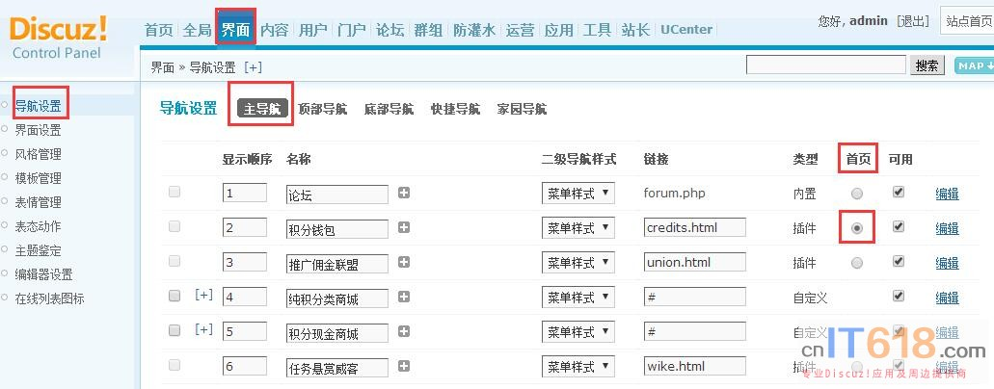   
  
**二、手机版的需要修改index，也很简单，可以用以下方法实现，如图：**  
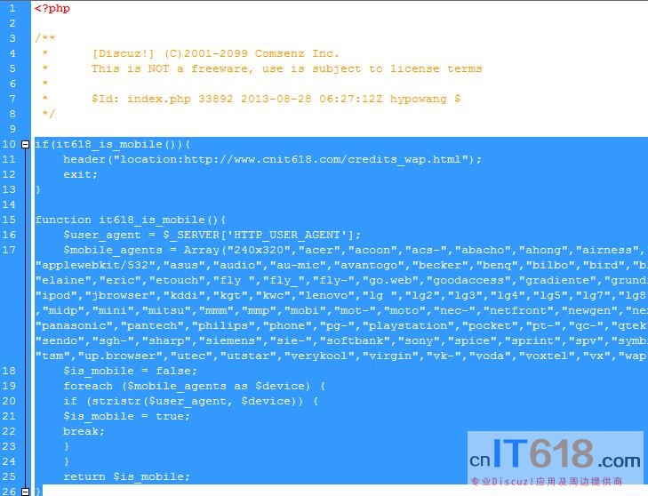   
  
**修改网站根目录下的index.php文件，直接在<?php下面的/*注释*/下面(如上图)第一行添加以下代码：**  
  
**注意：以下红色代码部分为要访问的首页链接，示例的链接是积分钱包首页，可以用手机访问**[**http://www.cnit618.com**](http://www.cnit618.com/)**，看看效果！**  
  
**也就是说以下红色链接换成你的链接！**  
  
  
**有时发现不能访问插件首页，而是强制跳转到论坛页，可以看这个教程：**《[Discuz3.2及以上版本 开启手机版后访问it618插件手机版自动跳转到论坛的解决方法](http://www.cnit618.com/thread-1476-1-1.html)》  
  
  
if(it618_is_mobile()){ //手机访问时跳转  
        header("location:你想设置的插件链接");  
        exit;  
}  
  
function it618_is_mobile(){   
        $user_agent = $_SERVER['HTTP_USER_AGENT'];   
        $mobile_agents = Array("240x320","acer","acoon","acs-","abacho","ahong","airness","alcatel","amoi","android","anywhereyougo.com","applewebkit/525","applewebkit/532","asus","audio","au-mic","avantogo","becker","benq","bilbo","bird","blackberry","blazer","bleu","cdm-","compal","coolpad","danger","dbtel","dopod","elaine","eric","etouch","fly ","fly_","fly-","go.web","goodaccess","gradiente","grundig","haier","hedy","hitachi","htc","huawei","hutchison","inno","ipad","ipaq","ipod","jbrowser","kddi","kgt","kwc","lenovo","lg ","lg2","lg3","lg4","lg5","lg7","lg8","lg9","lg-","lge-","lge9","longcos","maemo","mercator","meridian","micromax","midp","mini","mitsu","mmm","mmp","mobi","mot-","moto","nec-","netfront","newgen","nexian","nf-browser","nintendo","nitro","nokia","nook","novarra","obigo","palm","panasonic","pantech","philips","phone","pg-","playstation","pocket","pt-","qc-","qtek","rover","sagem","sama","samu","sanyo","samsung","sch-","scooter","sec-","sendo","sgh-","sharp","siemens","sie-","softbank","sony","spice","sprint","spv","symbian","tablet","talkabout","tcl-","teleca","telit","tianyu","tim-","toshiba","tsm","up.browser","utec","utstar","verykool","virgin","vk-","voda","voxtel","vx","wap","wellco","wig browser","wii","windows ce","wireless","xda","xde","zte");   
        $is_mobile = false;   
        foreach ($mobile_agents as $device) {   
        if (stristr($user_agent, $device)) {   
        $is_mobile = true;   
        break;   
        }   
        }   
        return $is_mobile;   
}